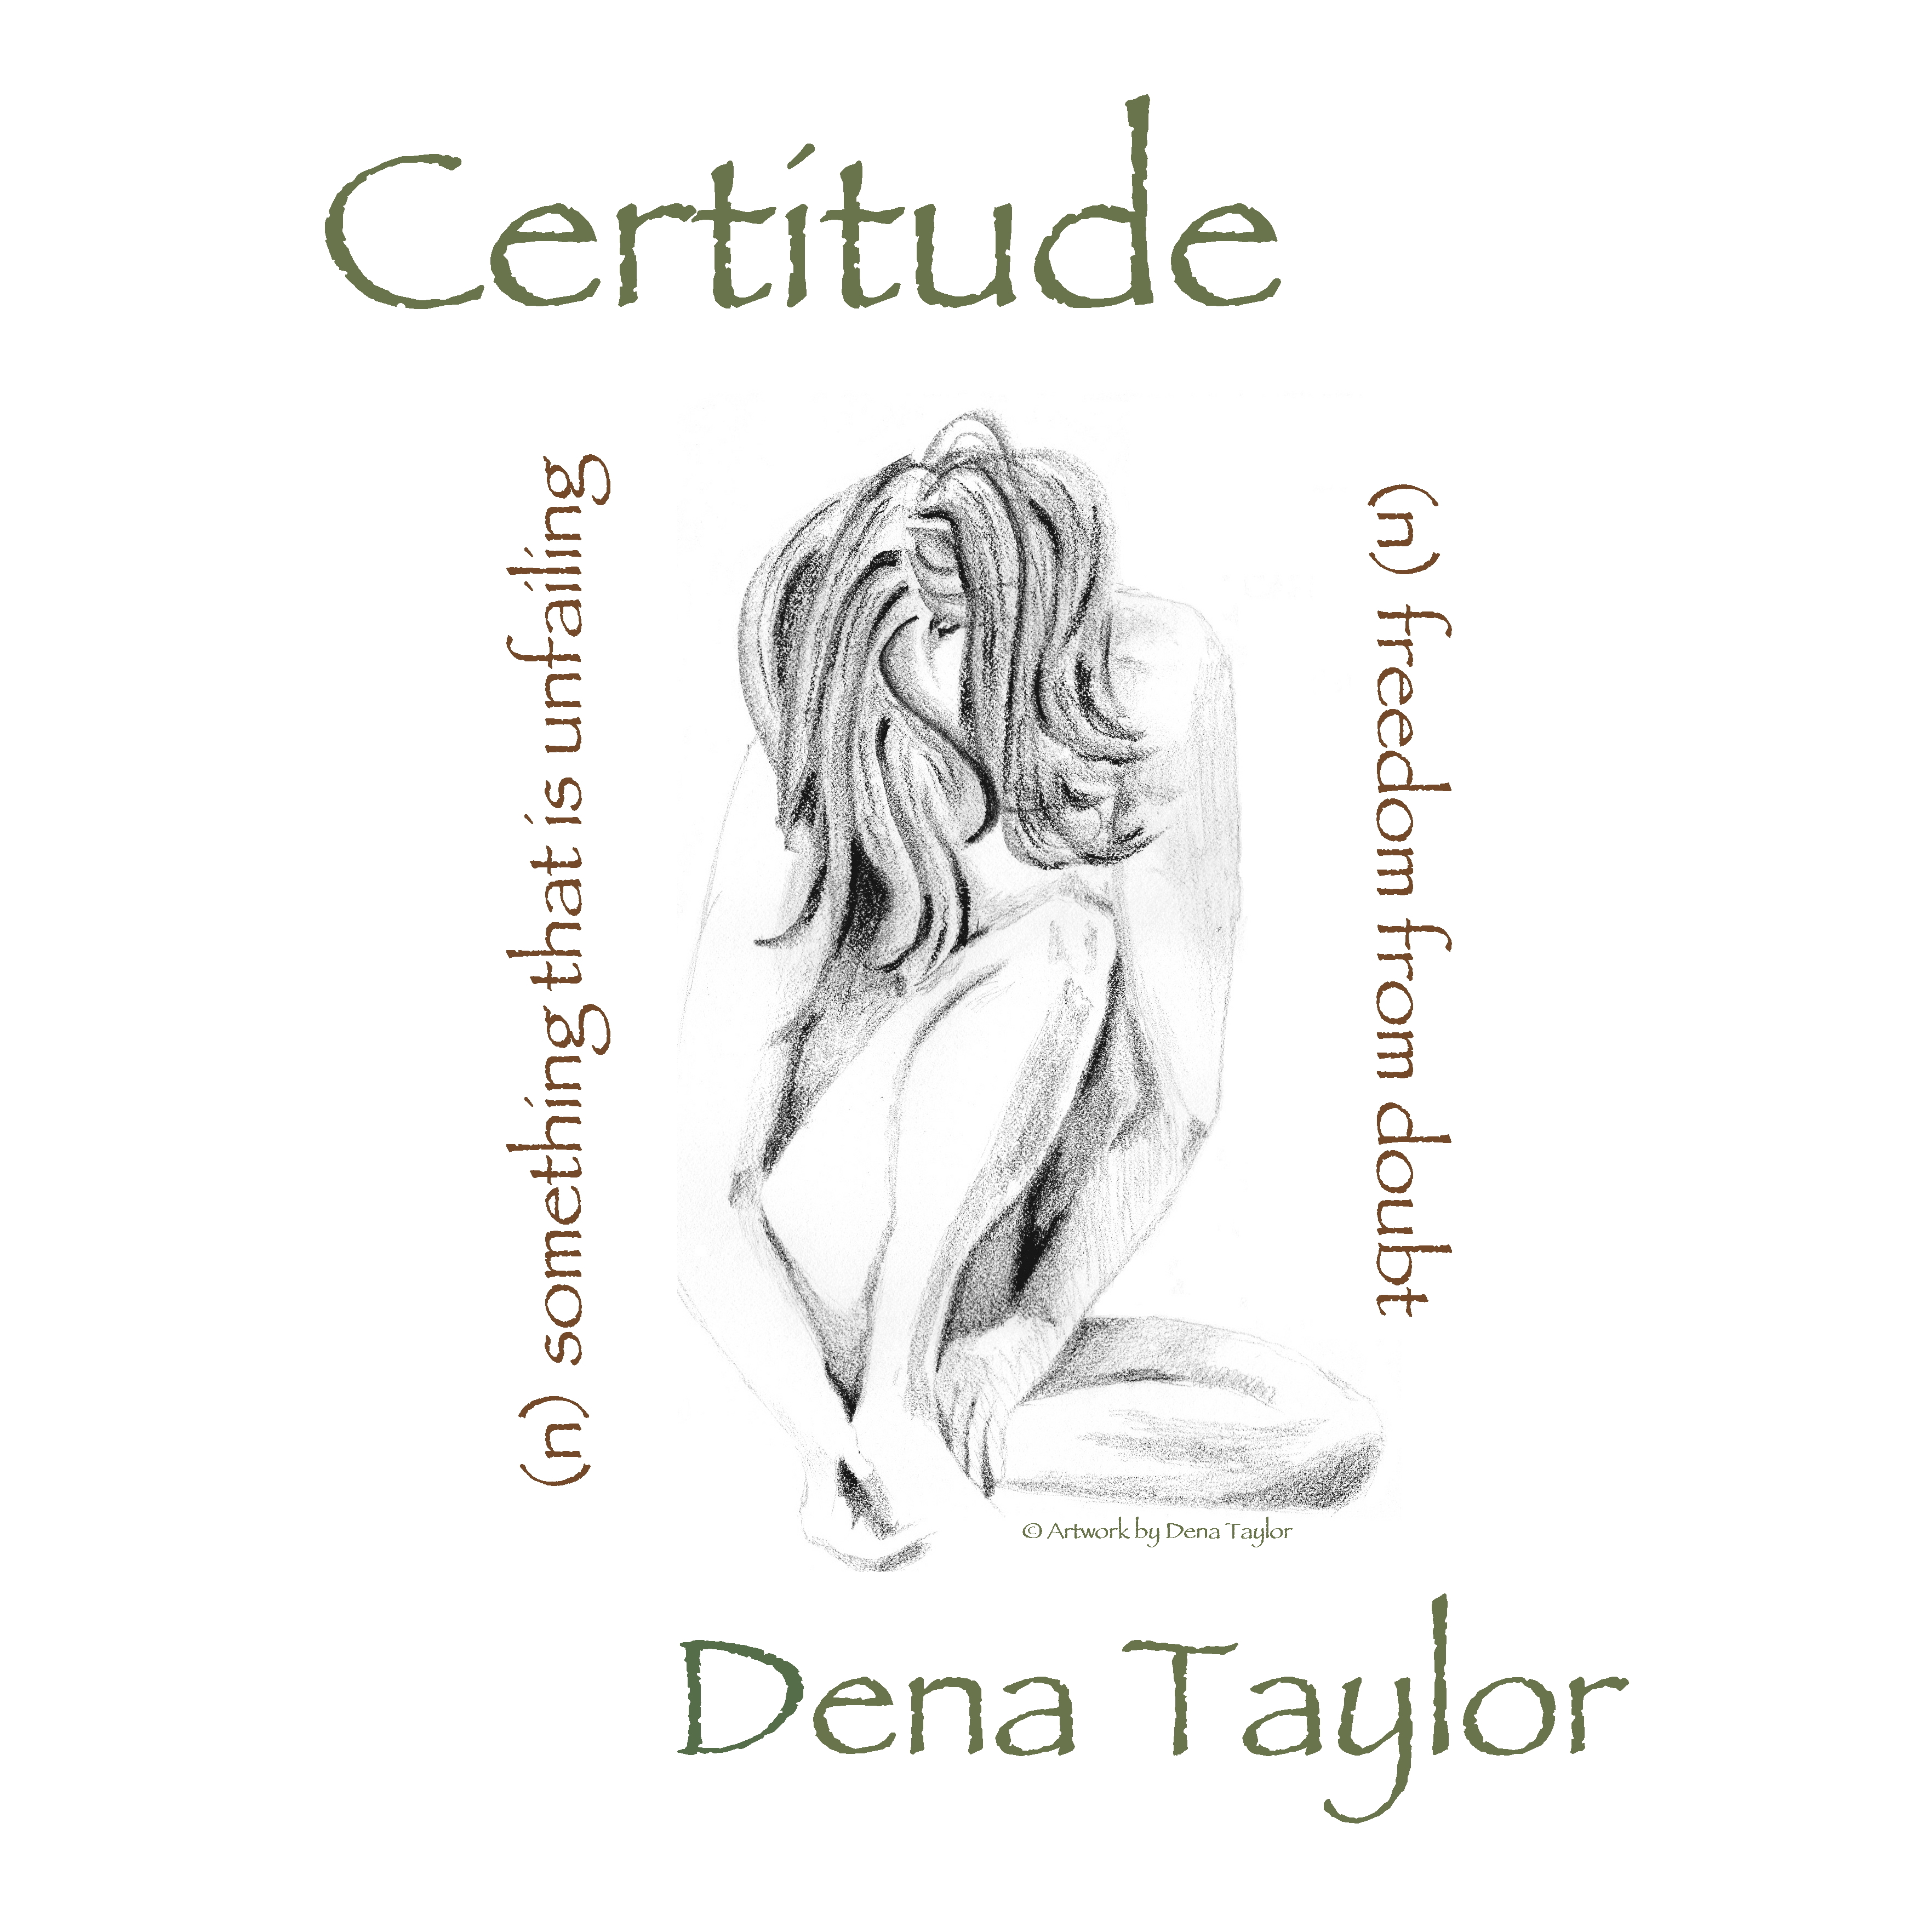
Certitude

Executive Producer: Dena Taylor
Producer: Matt Smith

Recorded & Mixed:
Lost Oasis, Austin TX

Mastered by Jerry Tubb at
Terra Nova Digital Audio, Inc., Austin TX

Release: August 2010

11 Tracks, Playing Time: 49 Minutes

Tracks:

What’ll I Do (3:00)
(I. Berlin • Irving Berlin Music Company)

Teach Me Tonight (4:23)
(S. Cahn, G. DePaul • The Hub Music Co., WB Music Corp. obo Cahn Music Co.)

Sway (3:07)
(L D T Molina, N. Gimbel, P B Ruiz • Peer International Corp.)

I Forget You Every Day (4:32)
(M. Haggard • Sony/ATV Tree Publishing)

The Man I Love (4:16)
(G. Gershwin, I. Gershwin • WB Music Corporation)

Song for My Father (4:38)
(H. Silver • Ecaroh Music)

Send In The Clowns (4:57)
(S. Sondheim • WB Music Corp OBO Rilting Music Inc.)

I Thought About You (4:37)
(J. Van Heusen, J. Mercer • WB Music Corp., Jerry Leiber Music, Range Road Music Inc., Silver Seahorse Music LLC)

Quiet Night of Quiet Stars (3:26)
(A. Jobim, G. Lees • Songs of Universal, Inc.)

One For My Baby (6:19)
(J. Mercer, H. Arlen • MPL Music Publishing obo Harwin Music Corp.)

Here We Go Again (3:56)
(D. Lanier, R. Steagall • Dirk Music)

Amongst the Southern inspired standards runs a ribbon of latin and jazz which creates a synergy that words cannot do justice. Let your ears experience this new style of easy listening jazz standards with a huge helping of country grits and a dash of habanero chile.

National Radio Promotion:

DA Productions
P. O. Box 1104
Buda TX 78610

For Radio Programmers:
http://www.airplaydirect.com/denataylorcertitude

Artist Contact & Booking: 321/243-6211

Dena Taylor Music
Information@DenaTaylorMusic.com
www.DenaTaylorMusic.com

Musicians:

Dena Taylor: Vocals
Lyn Daniels – Bass: #5
Ernie Durawa: Drums - #2, #4, #11
Aaron Lack: Percussion – #1, #3, #5, #6, #8, #9
Matt Smith: Vocals – #2, Guitars/Mandolin/Dobro – All tracks
Brad Taylor: Bass – All except#6, #7, #10
Redd Volkaert: Vocals – #11, Guitar – #4, #11

