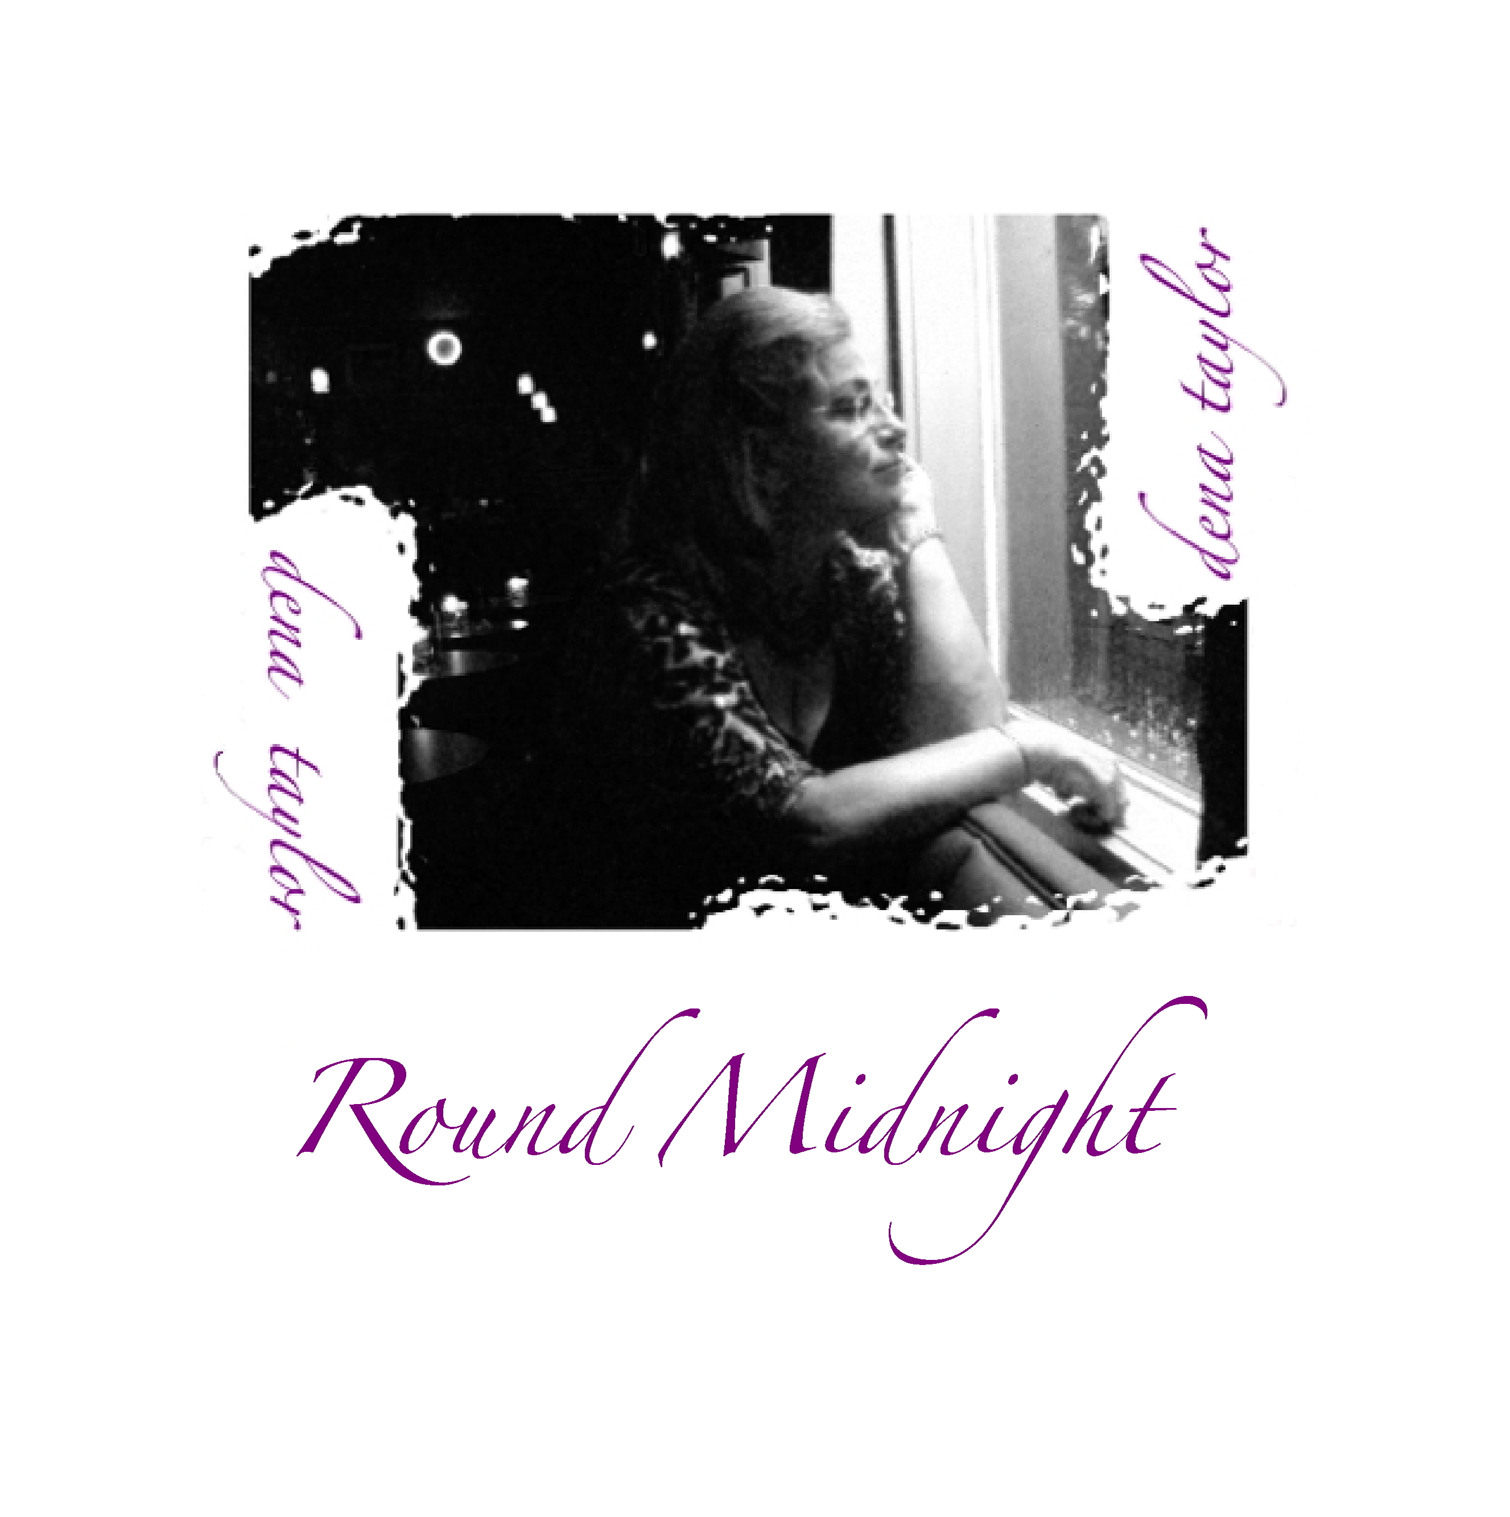
Round Midnight

Executive Producer: Dena Taylor
Producer: Mark Brasel

Recorded, mixed and mastered:
Zone Productions, Melbourne FL

Sound Engineer: Mark Brasel

Release: June 2008

9 Tracks (+ 1 Bonus Track), Playing Time: 43 Minutes

Tracks:

Too Close for Comfort (4:20)
(J. Box, G. Weiss, L. Holofcener • Range Road Music Inc.)
That Old Black Magic (4:42)
(H. Arlen, J. Mercer • Sony/ATV Harmony
Round Midnight (5:14)
(T. Monk, C. Williams, B. Hanighen • Warner Bros. Music)
Close Enough for Love (3:19)
(J. Bruce • WB Music Corp.)
I'm a Fool to Want You (4:30)
(J. Herron, J. Wolf, F. Sinatra • WB Music Corp. obo Sergeant Music Co.)
My Foolish Heart (4:40)
(V. Young, N. Washington • Catharine Hinen DBA Catharine Hinen Music)
Our Love is Here to Stay (5:18)
(G. Gershwin, I. Gershwin • WB Music Corp. obo George Gershwin Music)
Let's Face the Music and Dance (4:38)
(I. Berlin • Williamson Music Co. obo Irving Berlin Music Co.)

Musicians: Dena Taylor: Vocals, Dave Dunscombe: Drums, Ron Pirtle: Acountic Bass, Ron Teixiera: Keyboard

The jazz-tinged piano-ballads featured on Round Midnight, a selection from Taylor's latest album, combine a retro melancholy reminiscent of Ella Fitzgerald or Billie Holliday with a self-knowing wink and a nod - in all the tracks. It is clear that Taylor combines the power and passion of her deeper melodies with hip, even modern takes on a classic Cole-Porter sound.
National Radio Promotion:

DA Productions
P. O. Box 1104
Buda TX 78610

For Radio Programmers:
www.airplaydirect.com/denataylorroundmidnight

Artist Contact & Booking: 321/243-6211

Dena Taylor Music
Information@DenaTaylorMusic.com
www.DenaTaylorMusic.com

Distribution:
DenaTaylorMusic.com, Bandcamp, iTunes, Amazon, CDBaby

